To: Cape Elizabeth Town Council

From: Michael K. McGovern

Re: New England Cottontail Habitat

Date: September 23, 2011

For several years, federal and state wildlife agencies have noted the presence of New England Cottontail in Cape Elizabeth. We have worked cooperatively with the Rachel Carson Wildlife Refuge to protect this species listed on Maine’s endangered list and as a candidate species on the federal endangered list. We also note that local landowners have worked with these agencies in creating habitat and they have set a good example for us.

One area that has been identified as prime habitat for the NEC is some of the shrub swamp wet meadow and forested edges on the town owned Gull Crest parcel. The agencies have specifically identified 15 acres of land that is ideal for the NEC.

All of the 15 acres has been previously identified as appropriate for conservation and for low impact use such as for trails for walking and Nordic skiing. In discussions with ME Inland Fisheries and Wildlife, these uses remain compatible with an active program to manage habitat for the NEC on the 15 acres.

It is recommended that the Town enter into an agreement with Maine Fisheries and Wildlife to actively manage as NEC habitat 15 acres of the Gull Crest property. Most of the active management activities can be accomplished by public works during the off season and volunteer resources may also be available to assist. Out of pocket expense is believed to be minimal.

Trip Report
Prepared by Dorothy Fecske

Dates of Trips: July 8, 11, and 13, 2011
Location: Gull Crest
Participants: Dorothy Fecske (July 8, 11, and 13), Kelly Boland (July 11) of Rachel Carson NWR
Reason: Conducted site visits to Gull Crest to assess habitat for New England Cottontails and identify 15 acres for management.
The proposed New England cottontail management area at Gull Crest consists of about 15 acres of shrub swamp, wet meadow, and forested edge habitat, bordered on the east by a wetland and on the north, west, and south, predominantly by forested habitat (Figures 1 and 2). Woody plants comprising thicket and understory vegetation include speckled alder, winterberry, bush honeysuckle, arrowwood, black berry, blue berry, native rose, huckleberry, bayberry, hawthorn, juneberry, red osier dogwood, maleberry, spirea, and witch hazel. Overstory species include poplar, red oak, red maple, birch, white pine, spruce, and black cherry. Apple trees also are scattered throughout portions of the management area, within the shrubland and along the forested edge.

Proposed management:
Cottontail habitat within the management unit could be expanded by creating additional young forest habitat, enhancing shrubland development, and maintaining current thicket habitat. To create young forest habitat, potential management activities could include cutting and/or girdling about 1.5 acres of selected poplar stands (during winter) along the forested edge habitat (Figures 1, 3, and 4). In addition to facilitating root and stump sprouting, cutting or girdling small poplar stands would enhance development of thicket habitat by increasing the amount of light available to understory vegetation. To maintain shrubland habitat, trees > 3 inches in diameter that have emerged above the shrub canopy layer could be cut. Branches from cut trees could be used to construct brush piles, which are used as den sites by cottontails. Within the management unit, select red maple and white pine trees could be cut, but apple and cherry trees should be left on the site, as they provide a food source to cottontails.

Figure 1. Potential New England Cottontail Management Area at Gull Crest.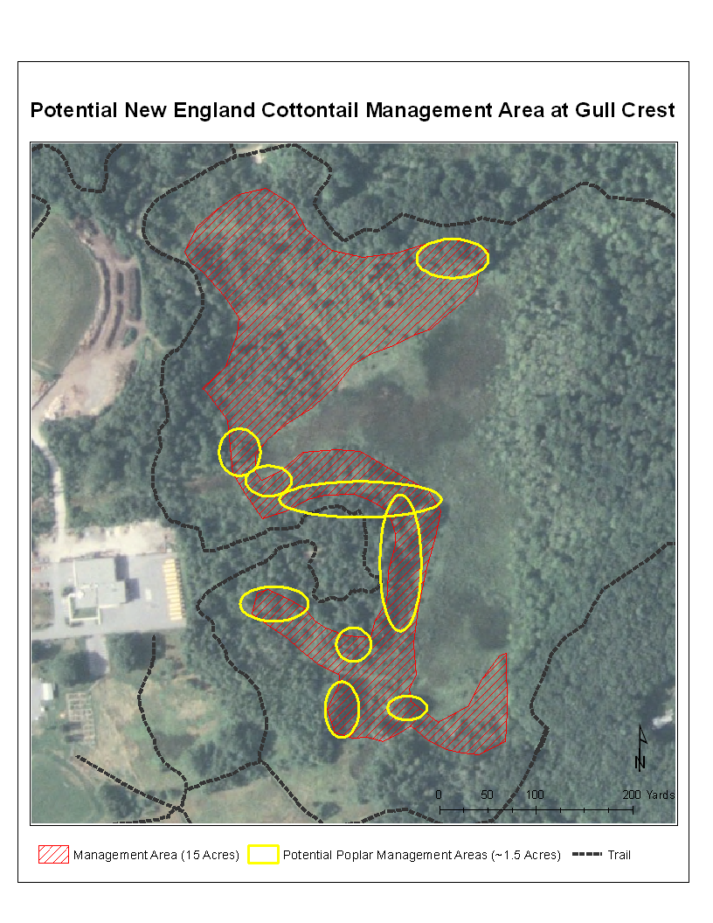

Figure 2. North end of proposed New England Cottontail Management Area. Image taken facing the wetland to the southeast.
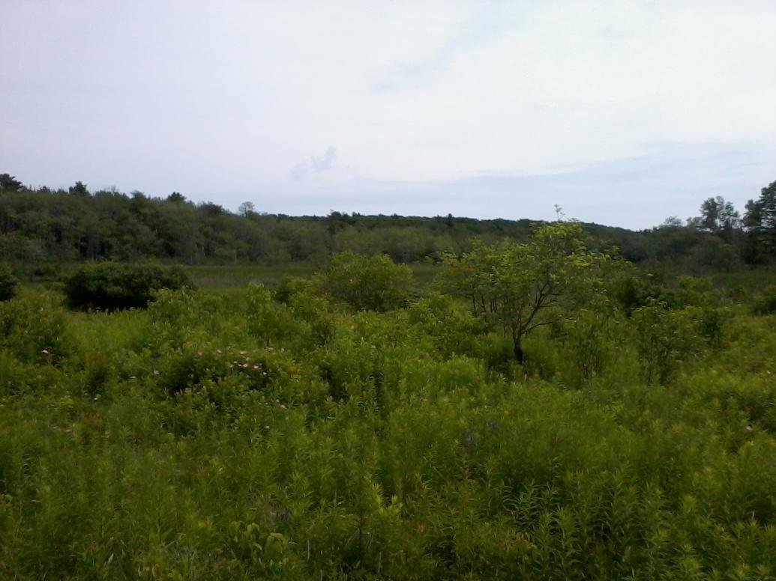

Figure 3. Forest edge habitat. Cutting or girdling poplars would facilitate root and stump sprouting to create dense young forest habitat and open the canopy, further enhancing shrub development for cottontails.
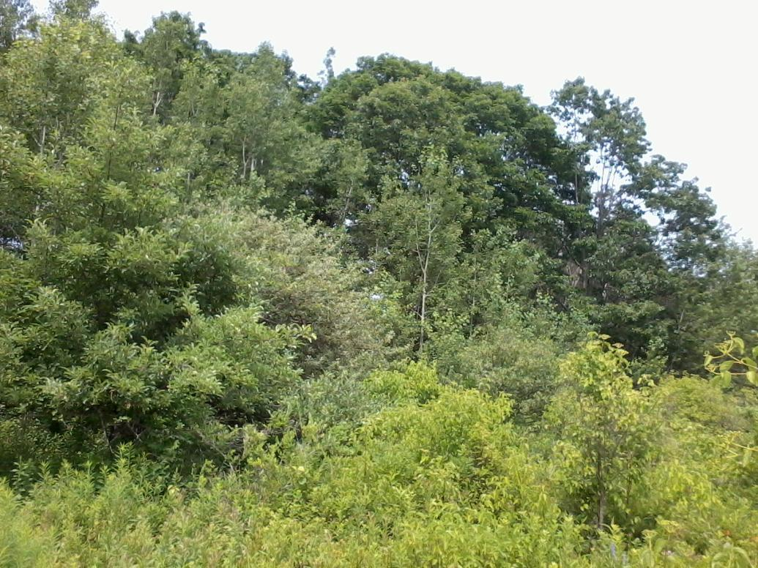

Figure 4. Facing a poplar stand that could be cut to enhance habitat for cottontails. Speckled alder on left and right side of the image.


